Internship Project Report
This is a report based on the Internship projects
given to us by InternJunction

Avik Chakraborty
Data Science Internship
InternJunction
l

Abstract—This is a project report based on the projects given during the Internship period at InternJunction. This report holds the detailed explanation and analysis of the algorithm used in every projects. The projects are based on real-world problems where Machine Learning and Deep Learning algorithms are used to analyze and predict the values.
Keywords—Pandas, Numpy, Keras, TensorFlow, Regression, Sequential, Models.

Introduction
In the era of digital transformation, data has emerged as one of the most valuable assets for organizations across various industries. Data science, an interdisciplinary field that utilizes scientific methods, processes, algorithms, and systems to extract knowledge and insights from structured and unstructured data, plays a pivotal role in harnessing this asset.
This project report delves into a comprehensive data science project aimed at Predictive Modelling, delivering Analytical Report and Detection of FAKE and REAL news. The primary objective of this project is to leverage data-driven techniques to uncover patterns, generate actionable insights, and ultimately support decision-making processes within the world of Data Science.
Models such as the Regression, Hyperclass Model, Neural Network has been used and then this model have been saved to the respective file paths using the TensorFlow’s Save method.

Project 1 : Orange Quality Rating Prediction
This project was based on the prediction of Orange Quality Rating. Predictive modelling have been used for this purpose and Linear Regression without Normalization have yielded the best result.

Linear Regression
Linear Regression is a statistical method used for modeling the relationship between a dependent variable and one or more independent variables. The goal is to find the best-fitting linear relationship (a straight line) that predicts the dependent variable. It assumes that the relationship between the variables is linear and that residuals (differences between observed and predicted values) are normally distributed. This model is widely used for forecasting and predicting continuous outcomes.

Results
The following were the results obtained:
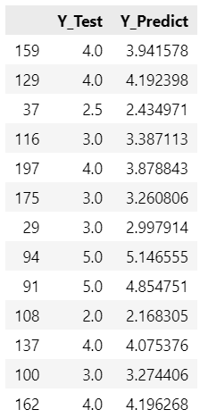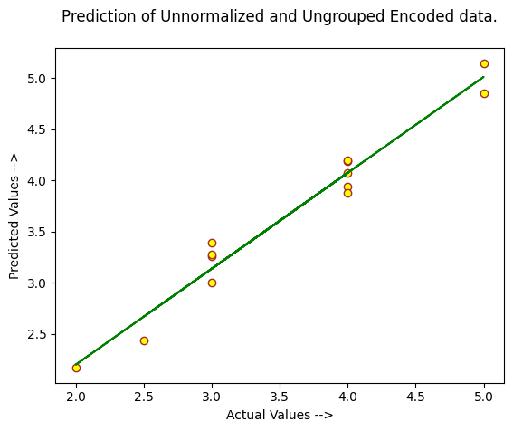

Heart Disease Prediction
This project focused on the prediction of the heart disease. Predictive modelling has been used and model have been improved using hyperparameter tuning. Hyperclass Model have been used for accomplishing this task.

Hyperclass Model
Hyperclass Model is a more general term and not a standard term in machine learning. It might refer to advanced or meta-level models that combine or integrate different algorithms or techniques. For example, it could involve hyperparameter tuning or ensemble methods where multiple models are combined to improve performance.

Building the model on the best hyperparameter
- The following shows the best hyperparameter
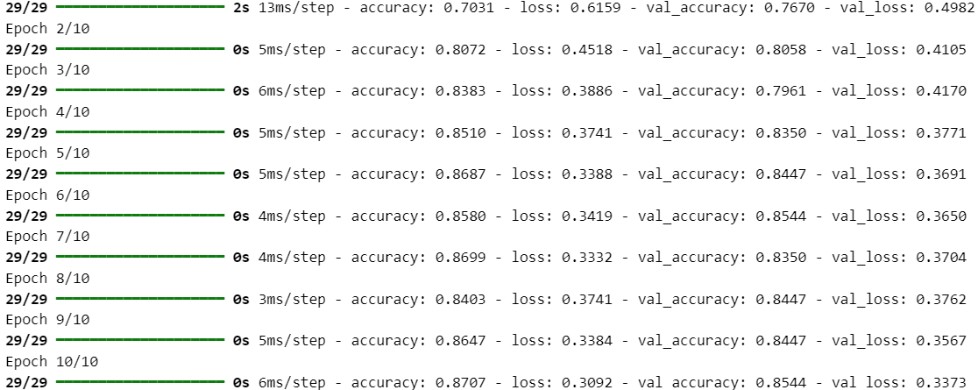
- Model Evaluation.

Confusion Matrix
Identify applicable funding agency here. If none, delete this text box.
A Confusion Matrix is a performance measurement tool used to evaluate the effectiveness of a classification model. It presents a table that summarizes the performance of the model by comparing the predicted labels to the actual labels.
True Positives (TP): The number of instances correctly predicted as the positive class.
True Negatives (TN): The number of instances correctly predicted as the negative class.
False Positives (FP): The number of instances incorrectly predicted as the positive class.
False Negatives (FN): The number of instances incorrectly predicted as the negative class.
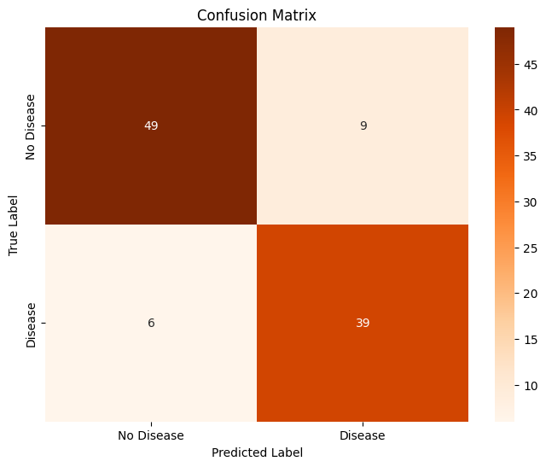

Classification Report
- A Classification Report provides a detailed overview of a classification model's performance by summarizing various metrics for each class in the dataset. The following are the necessary terms:
  - Precision: The ratio of true positives to the sum of true positives and false positives, indicating how many of the predicted positive instances are actually positive.
  - Precision: The ratio of true positives to the sum of true and false positives.
  - Recall (Sensitivity): The ratio of true positives to the sum of true positives and false negatives.
  - F1 Score: The harmonic mean of precision and recall.
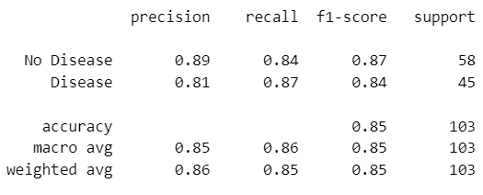

News Detection
This project focused on the prediction of the fake and real news detection. Predictive modelling has been used. Naive Bayes model have been used.

Naive Bayes
Naive Bayes is a probabilistic classification model based on Bayes' Theorem. It assumes that the features used for classification are independent of each other given the class label. This "naive" assumption simplifies the computation and makes the model efficient, especially for large datasets. It is particularly effective for text classification tasks, such as spam detection or sentiment analysis, due to its simplicity and performance.

Confusion Matrix
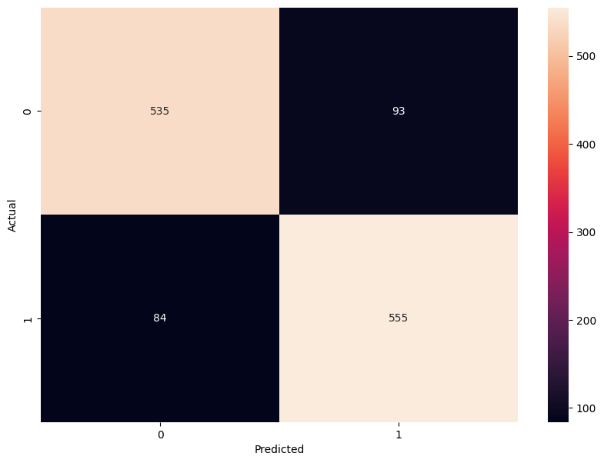

Classification Report

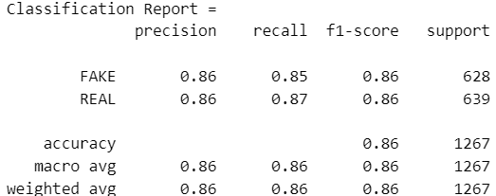

Error Analysis
Error Analysis is the process of examining the mistakes made by a model to understand and improve its performance. It involves systematically evaluating where and why errors occur to identify patterns or specific areas of weakness
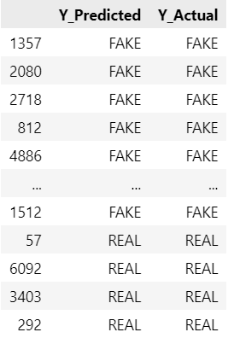

Conclusion
Accuracy
Project 1 | Project 2 | Project 3
0.9528752902600035 | 0.8543689250946045 | 0.8602999210734017
- Figure showing the accuracy after model selection in each project.

Acknowledgment
I would like to take this opportunity to extend my thanks to InternJunction for providing me with this Internship opportunity, where I can showcase my skills and knowledge.

*****************************************************************

